|  |  |  |
| --- | --- | --- |
| S.No | CONTENT |  |
| 01 | ABSTRACT |  |
| 02 | PROBLEM STATEMENT |  |
| 03 | PROPOSAL SOLUTION |  |
| 04 | DESIGN AND ARCITECTURE |  |
| 05 | COMPONENTS AND MODEL |  |
| 06 | ISSUES AND SOLUTIONS |  |
| 07 | CONCLUSION |  |

REPORT

# ABSTRACTS.

A technical advancement called the “Smart Stick for Blind Person” is intended to increase the independence and security of those who are blind or visually impaired. To produce an intelligent navigation tool, this device merges cutting-edge sensors, networking, and assistive technologies. In order to detect obstacles in the users route, the smartstick uses ultrasonic or LiDAR sensors, providing real-time input through vibrations or audible cues. To provide precise location monitoring and directional guidance, it also combines GPS and inertial navigation technologies.

# PROBLEM STATEMENT

The most challenging situation faced by any visually impaired persons is that they find it difficult to interact and feel their environment.

Physical movement is a challenge for such people because it can become uncertain to distinguish any kind of obstacles that appear in front of them and this becomes a barrier to move from one place to another.

A camera can be used to capture the image/obstacle in the user’s path and send an alarm through the user’s Smartphone where the message will be read to the user.

When the prograam will Capture images it may face some issues like extra lights,and the humadity of environment can cause a blur scens on camera.

Mobility and Navigation: It can be challenging for blind persons to move around on their own. Using public transit, navigating through unfamiliar settings, and dodging obstacles can be difficult.

Information Access: It can be challenging for blind people to access printed materials, visual content, and information given in graphical representations. Reading books, newspapers, webpages, and other visual media are included in this.

Education: Access to educational resources like textbooks and visual aids may be difficult for blind pupils. To make sure kids receive a decent education, specialized resources, tools, and training are frequently required.

Many job choices for blind people may be limited, and workplace conditions may not be conducive to their success.

# PROPOSED SOLUTION,

Visual impairment significantly impacts an individual&#39;s independence and mobility. To address this challenge, we propose the development of a cutting-edge &quot;Smart Stick&quot; that integrates advanced technologies to enhance the lives of blind individuals. This assistive device aims to provide real-time navigation, obstacle detection, environmental information, and communication capabilities, all in a user-friendly and portable package.

# DESIGN AND ARCITECTURE,

# COMPONENTS AND MODEL:

SENSORS:

## RASPBERRY PI:

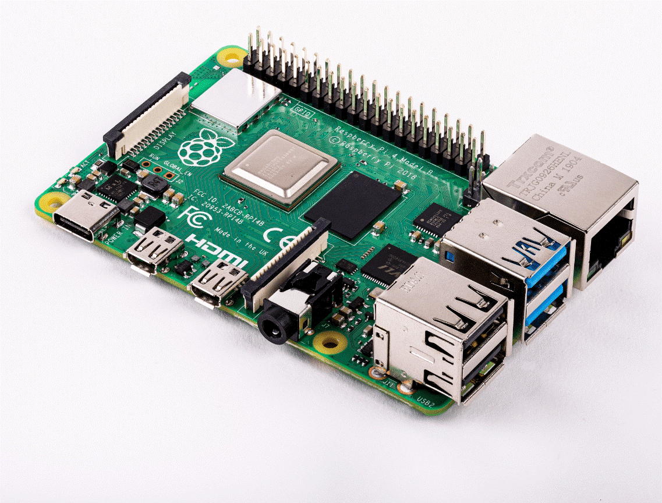The working of the system begins when the power

supply is given. The ultrasonic sensor is then used to

detect obstacle and provides distance between

obstacle and the device. GPS Module provides

navigation. When obstacle is detected, the distance

and the navigation will be processed using Raspberry

Pi device.

## AUDIO SENSOR:

The smart stick for the blind, as its name suggests,

is a tool for people who are blind or visually

impaired to help them find their way while avoiding

obstacles. It employs two HC SR 04 ultrasonic

sensors to measure the distance between obstacles

or the depth below.

## WATER LEVEL SENSOR:

What does the smart blind sticks water sensor do?

The water sensor module will measure the water

level and transmit that information to the Arduino

Uno microcontroller, which will use the information

to determine whether or not the blind user needs

to move in a certain direction if water is detected in

front of them.

COMPONENTS:

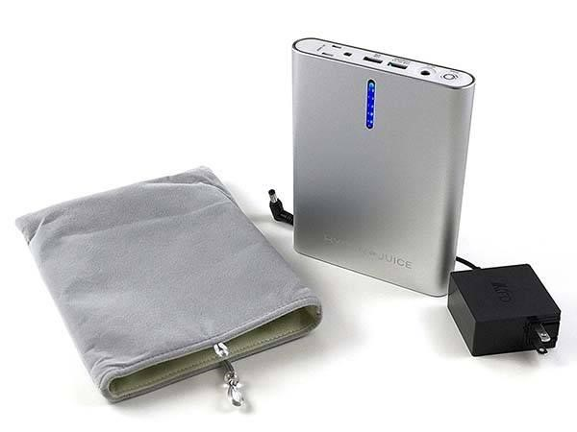

## BATTERY:

In many electrical devices, like smart sticks,

batteries are crucial parts. They supply the required

electricity to run the devices electronic circuits and

parts.

## BUZZER:

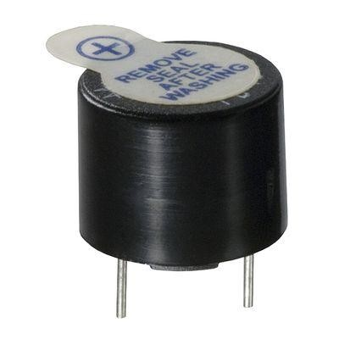The ultrasonic sound sensor is incorporated into the

stick so that the buzzer will only sound when an

obstruction is detected by the system. In order for

someone who is blind to recognize which side is

clear of obstacles. And various beep sound effects

will be made for various sides.

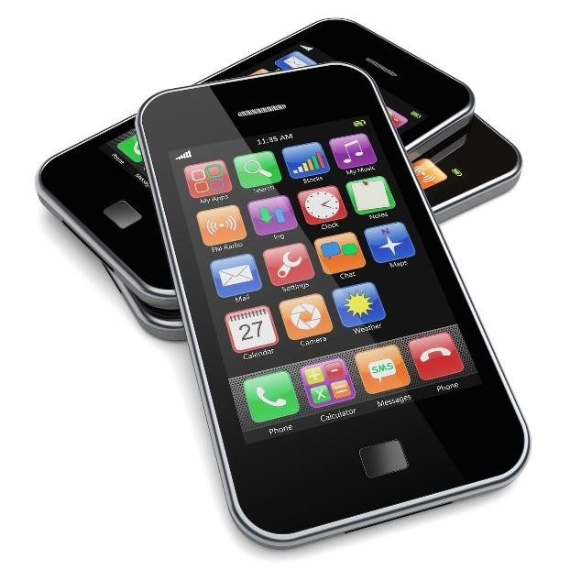

## SMARTPHONE:

Wireless technologies like Bluetooth are frequently

used to connect a smartphone to a smart walking

stick. With the help of this link, the smart walking

stick may talk to a smartphone and perhaps provide

functions like tracking, alarms, and remote control.

The connecting procedure might go like this:

## PIR SENSOR:

PIR sensor is like a special gadget that can notice

when theres movement around. It does this by

feeling the heat that people or animals give off.

When it senses this heat change, it tells other

things, like lights or alarms, to turn on. So, it helps

make things work automatically when someone

walks by.

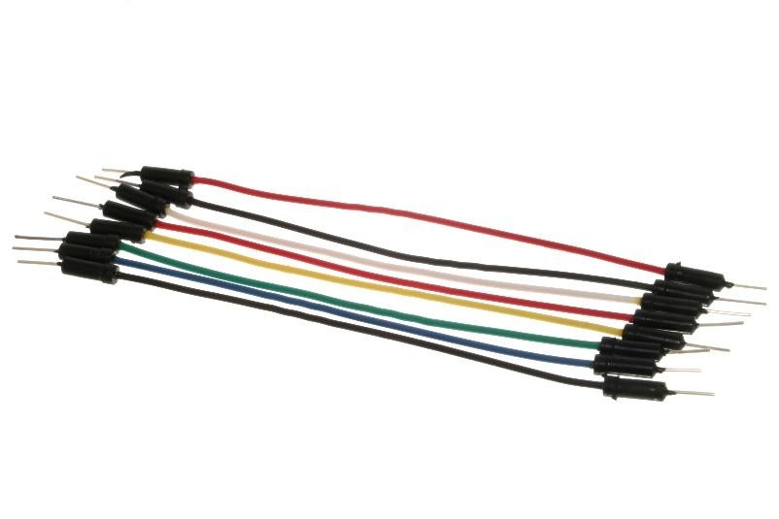

## JUMPER WIRES:

A jumper wire, which is frequently used in electrical

and electronic circuits, can help make smart walk

sticks more useful. A smart walk stick is a tool made

to help people who have vision problems or

mobility issues navigate their surroundings more

efficiently.

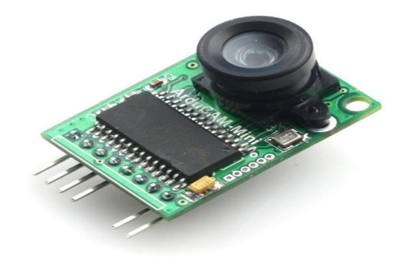

## CAMERA:

Technology is frequently included into a smart

walking stick with a camera to improve the users

experience and safety while walking.

# ISSUES AND SOLUTION:

# CONCLUSION:

The smart walking stick is a key development in assistive technology that is intended to improve the

independence and mobility of people who face different levels of mobility issues. The smart walking

stick provides a number of advantages above and beyond those provided by conventional walking

aids thanks to the integration of numerous sensors, connection features, and cutting-edge

algorithms.As a result of its real-time input, increased safety, navigational help, and greater connection, thesmart walking stick has the potential to completely transform the lives of persons with mobility

issues. We may anticipate significant advancements in this area as technology develops further,

resulting in even more complex and convenient smart walking sticks that are tailored to the special

requirements of those with mobility issues.